Project 5

Hospital Management

1. Use Case Hospital Management:

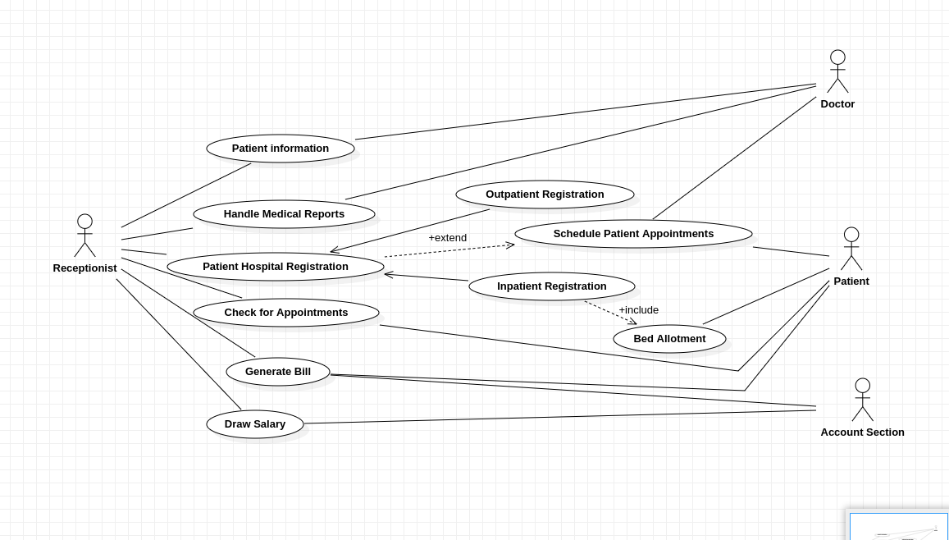

2. Sequence Diagram for Hospital Management:

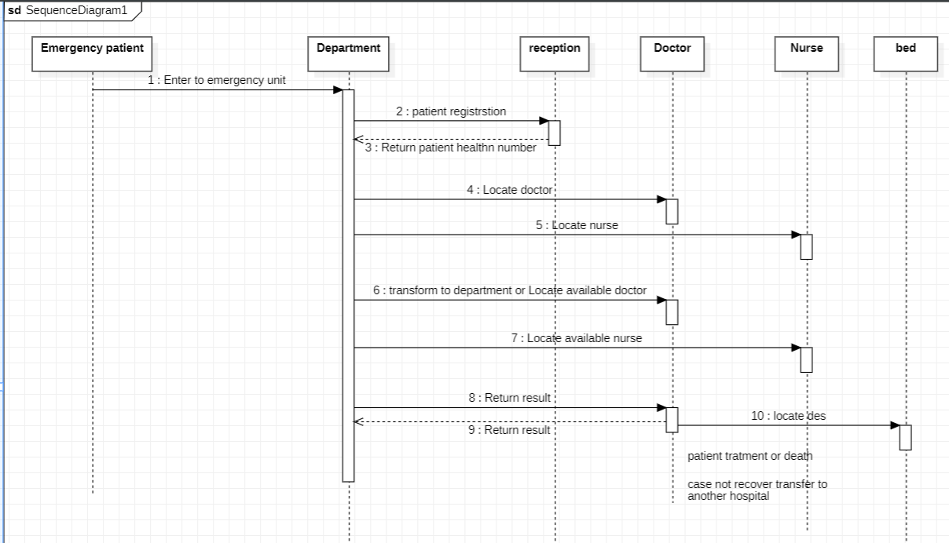

3. Collaboration Diagrams for Hospital Management:

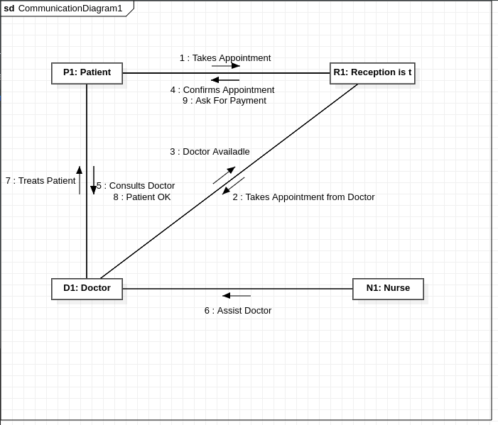

4. Deployment Diagrams for Hospital Management:

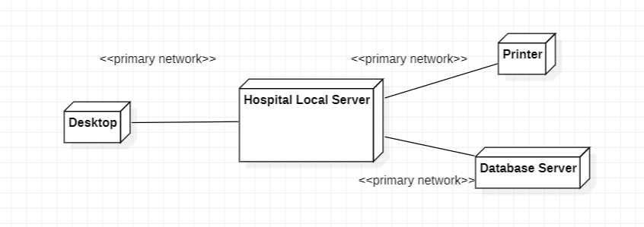

5. Component Diagrams for Hospital Management:

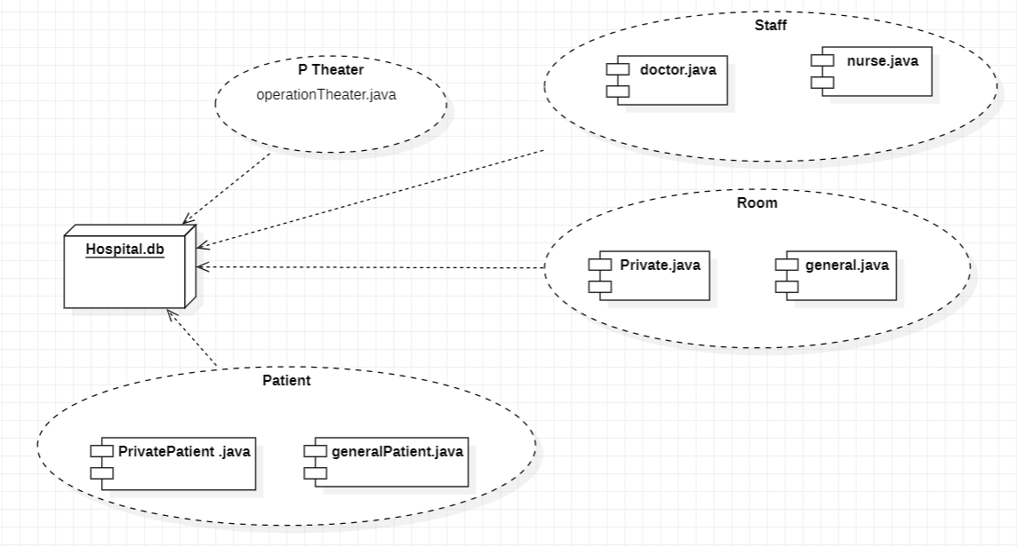

6. Class Diagrams for Hospital Management:

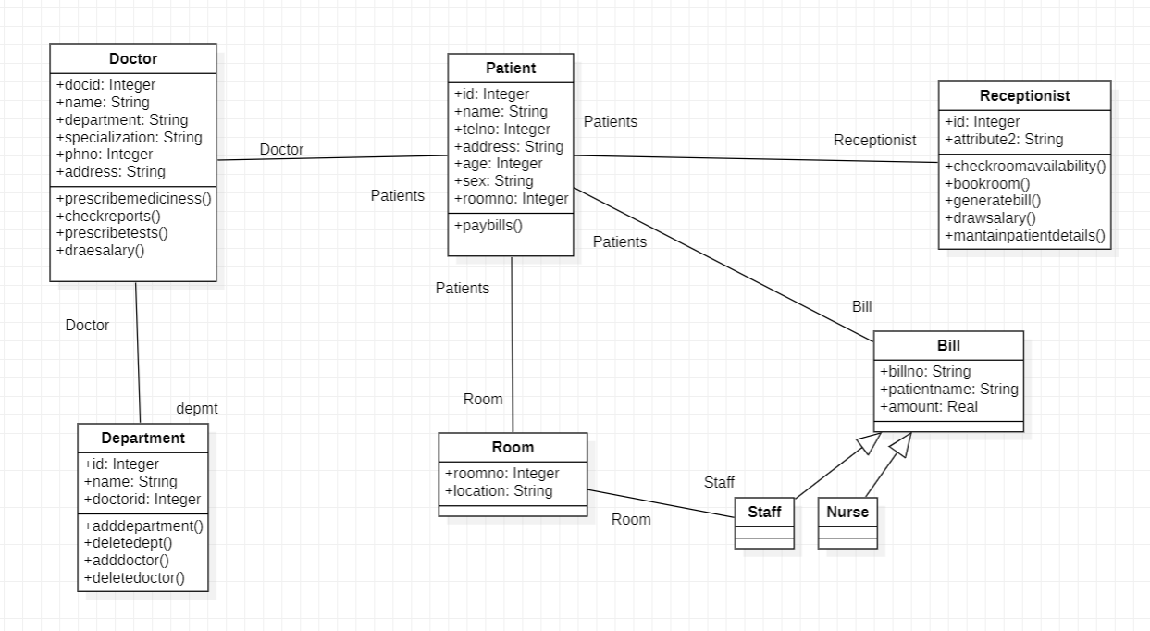

7.Activity Diagrams for Hospital Management:

